1. **Which are the top three variables in your model which contribute most towards the probability of a lead getting converted?**

A: The top Variables that contribute towards the probability of getting converted are –

* 1. Total Time Spent on Website
  2. Lead Origin_Lead Add From
  3. Last Activity_Had a Phone Conversation

1. **What are the top 3 categorical/dummy variables in the model which should be focused the most on in order to increase the probability of lead conversion?**

A: The top 3 categorical / Dummy Variables that should be focused on to increase the probability of conversion are:

* 1. Lead Origin_Lead Add From
  2. Last Activity_Had a Phone Conversation
  3. Last Notable Activity_Unreachable
  4. What is your current occupation_Working Professional

1. **X Education has a period of 2 months every year during which they hire some interns. The sales team, in particular, has around 10 interns allotted to them. So during this phase, they wish to make the lead conversion more aggressive. So they want almost all of the potential leads (i.e. the customers who have been predicted as 1 by the model) to be converted and hence, want to make phone calls to as much of such people as possible. Suggest a good strategy they should employ at this stage.**

A:In order to make the aggressive calls, we could use 0.4 as the lead score cut-off. From the below diagram - we could say that out of 88% of the people that were called, we could see a conversion rate of around 77%.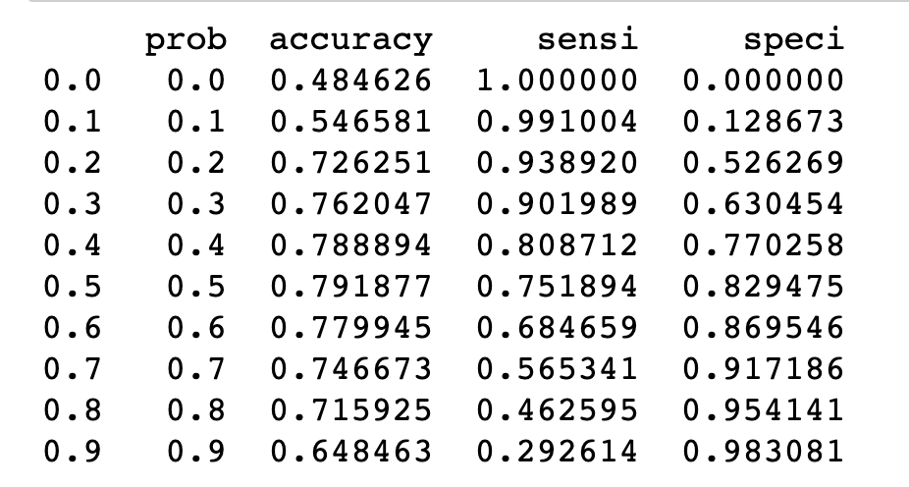

1. **Similarly, at times, the company reaches its target for a quarter before the deadline. During this time, the company wants the sales team to focus on some new work as well. So during this time, the company’s aim is to not make phone calls unless it’s extremely necessary, i.e. they want to minimize the rate of useless phone calls. Suggest a strategy they should employ at this stage.**

A: Since we are trying to convert maximum number of people by making minimum calls, we could use 0.7 and 0.8 as the cut-off

With the cut-off 0.7 - Out of 56% people that were called, we could see a conversion rate of 91%.

With the cut-off 0.8 - Out of 46% people that were called, the conversion rate is 95%.